The second generation I-Pod (instrument pod) by Steve Roake
Over a particularly quiet Christmas break in 2005, whilst bored I decided it was time I improved my hopper flying experience. I had analysed what was the worst part of the flying experience and what was the most time consuming part of the process, and the answer was tying all your instruments in place having inflated the balloon. The sheer amount of wasted time and gas in what is a gas limited environment was apparent and anything that could speed up the process had to be of benefit. The answer was obvious, I needed an instrument panel that would house everything and speed up the pre-flight preparation. The available of the shelf options didn’t “float my boat”, so I was going to have to create my own. Size was also a critical thing since I envisaged this panel sitting on my lap once in the seat arrangement. Some cardboard templating with instruments then gave me the basis of my panel, and then it was just down to what was the thing going to be made out of and what was my desired level of finish. From work I had managed to scrounge some 10mm MDF fibre board and some Rohacell core which I had machined down to a 30mm thickness.
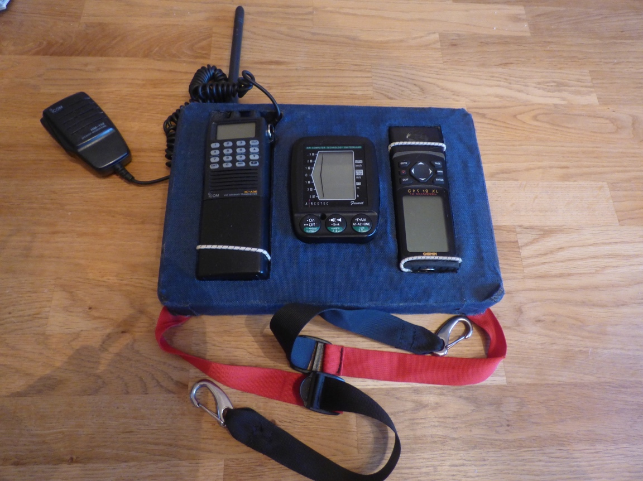
Using a template, I traced out where I wanted which items on the Rohacell and set about cutting out the core including a hole for the radio aerial to protrude through. Then I set about sticking the core to the MDF board and started cutting and applying the Cordura covering which would give the product some weather and dirt resistance. Once all the areas around the instruments were covered I could consider the attachment of the straps and D rings before finally covering the outside section to complete the task. The Variometer was fixed utilising its own screw from the reverse side, and the other instruments were held in place using elastic strapping.
Showing how rugged this design was, I have used it from 2005 until 2015 with very little maintenance or repairing. So why change now and make a mark two version? If it works why fix it?
Time moves onwards and so does technology. Hopping is about keeping it simple for sure but reluctantly I saw the potential for moving map technology and how it can assist your flight management and help you to decide where and when you are going to land without having to grab the map case. Christmas 2014 I convinced myself I would buy an I-pad Mini with the express view of utilising “moving maps” in all of my flying so in the application of hopping the obvious choice was to evolve the instrument panel to include the new addition.
Templates followed with the remit to keep the four instruments as small as possible and to be fair even with an I-pad measuring 200mm x135mm, the overall width has only increased by 80mm and the length by 90mm.
Once the idea of manufacturing a new instrument pod was sewn in my mind then came time to get the materials. The Cordura cloth which would cover the final version was purchased from Zebedee List at a very reasonable £10 for the 1 metre squared amount. The MDF board and the Rohacell inner core was “sourced” for free via friends in the motor trade and then it was really down to getting cracking on the project. I decided that along the way I would take periodic photographs to show the cloudhoppers community how the task was progressing and if anyone wanted to adapt the design to suit themselves, the various stages were documented for all to see.
The first task was to template the design and see how the instruments could be arranged so that the new panel was still small enough to not be a burden in use.
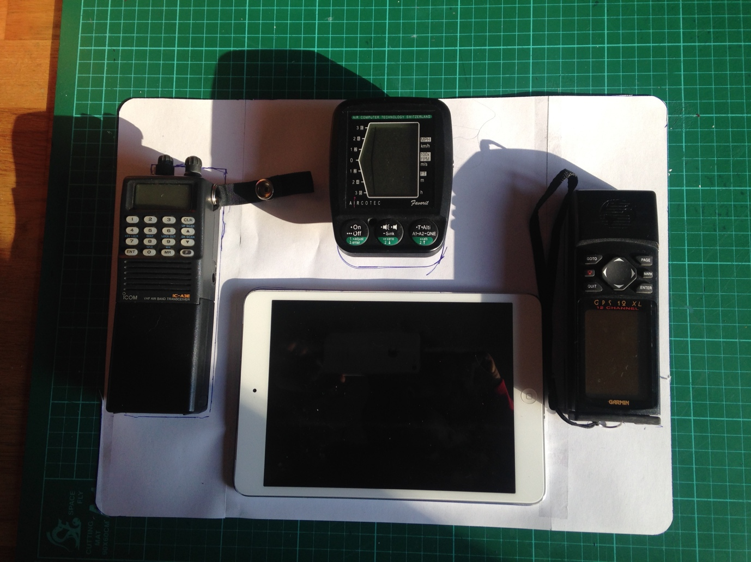
After some changing around, the final arrangement was decided along the lines of the above photograph. Once the instrument positions were set in stone the template could then be cut around and used to mark out on the Rohacell core the exact cutting places (which was really the only part of the whole task I dreaded, because I only had two pieces of the core and couldn’t afford to scrap them). The answer was simply to take more time and consideration and cut the main bulk of the core away leaving enough of the edging so that finite accurate sanding could be done one instrument position at a time.
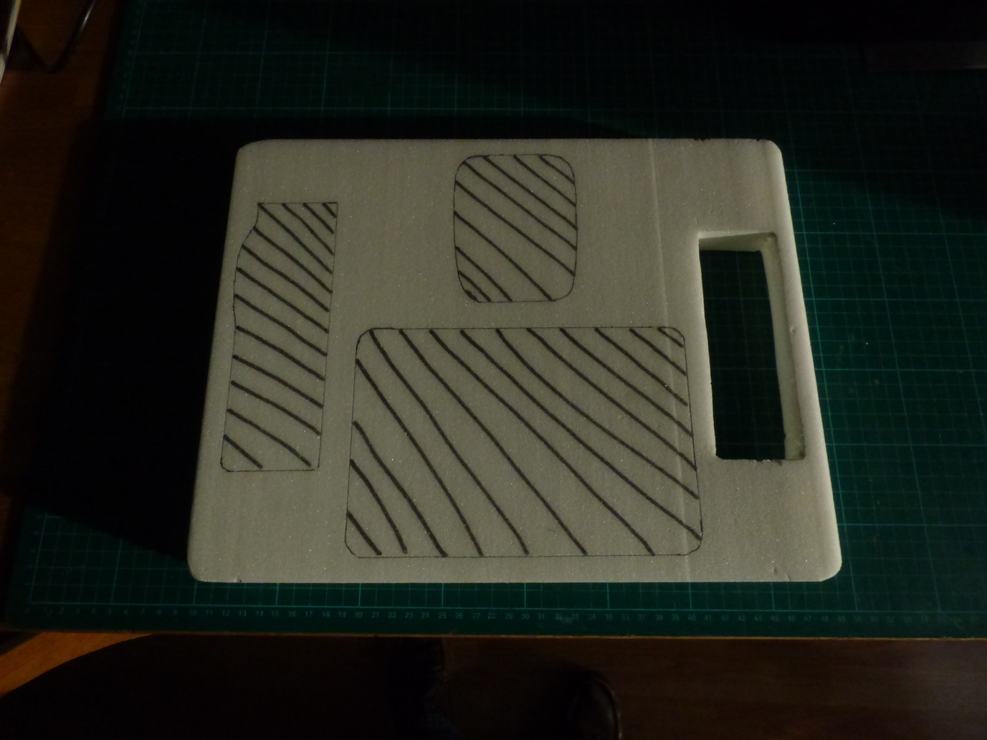
This also ensured that the fit of the instrument into its recess was both snug and to my satisfaction. I certainly didn’t want a sloppy fit and whilst most instruments would be held in place with elastic for protection, it was my desire that they would if possible be a push fit where the the edges would hold them in place. The actual hardest instrument position to cut was always going to be the radio position on the left hand side, because as well as opening up the recess for the main body of the Icom A3 radio it would also require an accurate hole inserted horizontally for the stubby aerial to protrude through. Therefore, I left this one till last and concentrated on covering the interior fitment of the other three instrument positions until I felt braver!
The instrument pod was also going to utilise the same attachments as used on the mark one version so successfully. Some adjustable straps with nice locks would be stuck to the underside of the MDF base board, but I needed a trip to Easy Balloons for John to produce a couple of new straps for me. I had the lengths already sorted out successfully and so it was just a case of removing one part from the mark one and with new sewn sections attaching them in place. My thanks to John for his assistance as I don’t own a sewing machine.
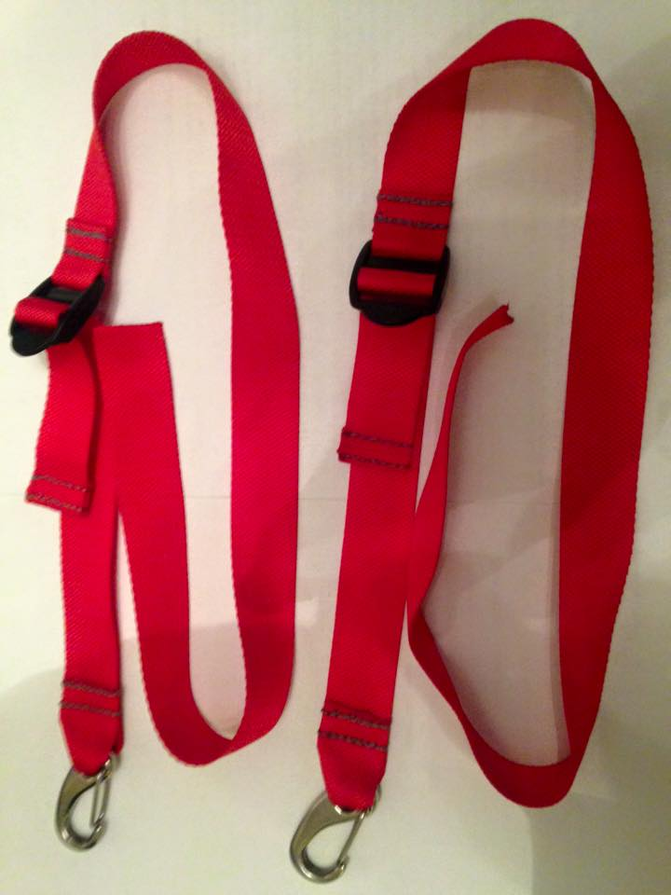
Beautifully finished with those lovely clamps, these really give a professional look to the home build. These were then super glued to the reverse side of the MDF board and awaited the mating of the core before being filled and covered in Cordura cloth.
My biggest concern from the manufacturing stance was how to glue the Rohacell core to the Cordura cloth. My previous version of the instrument pod had (to my knowledge) been made out of a lesser grade of Rohacell and the one supplied to me this time around is classified as 71 grade which is the densest and hardest. Whilst this wasn’t a problem, initial tests with the “super-glue” showed that the bonding wasn’t great and so I turned to the Cloudhopper’s Facebook page and asked the professionals for their opinions on what to use. With thanks to all those who responded, the unanimous reply was Evo-Stik contact adhesive.
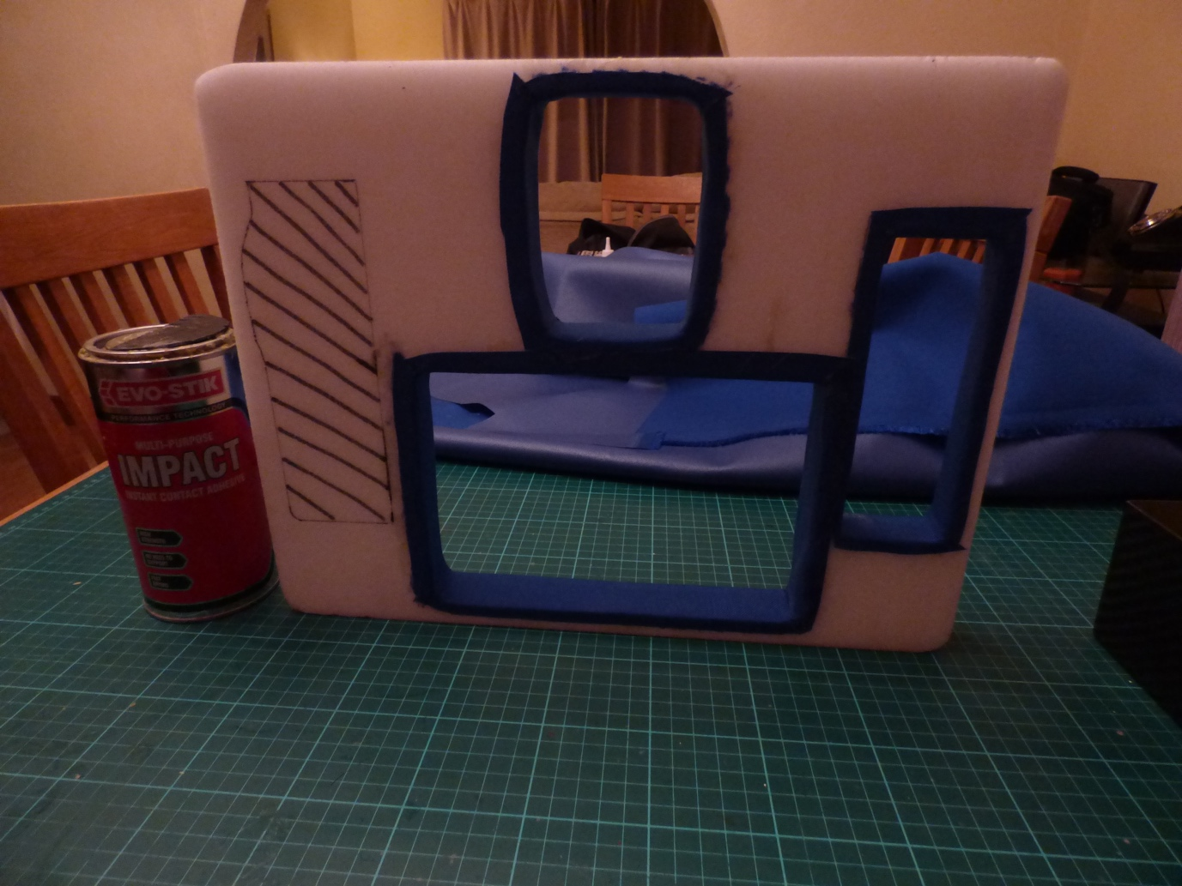
The only bug bear with this type of glue is the time you need to leave each piece before you can tack it together. 5 minutes’ minimum is suggested after coating both parts, but what you forget is that not only are you fixing the mating sidewalls of the pod, you then have to do both the flanges and so each and every section of cloth once cut to suit, takes 15 minutes to perfect.
Needless to say, production was staggered over a number of days with the glue work hardening over 24 hours, and by the time the final result was achieved I had used 600 grams of glue and my wife was sick of the smell as I worked away at the dining room table each day.
Eventually I had all the interior work completed and it was a case where the next stage was to mount the core section to the MDF base unit. Again 24 hours was required to achieve maximum bold and then I could start the process of wrapping the outer surfaces in Cordura, in the knowledge that I would fill all the inner spaces for an even coverage prior to the final “bullshit” finished layer.
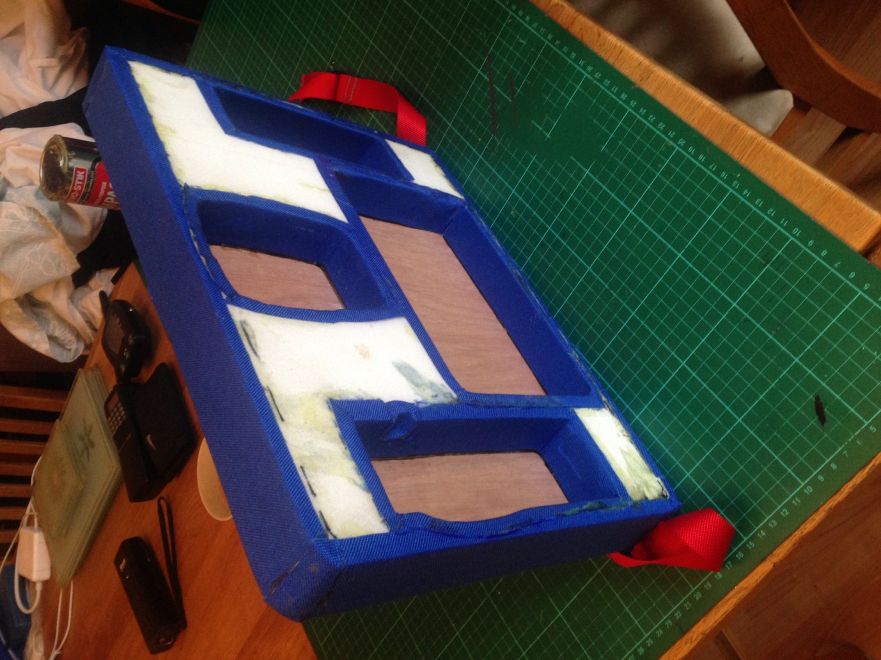
Once the edging had been completed I could concentrate on making the necessary drill holes for the instrument retentions, and then cover the exposed areas with Cordura for a finished look.
The interest that this project generated on Facebook surprised me, as I wasn’t aware that others would be keen observers, and my motivation was driven by my own specific needs rather than those of others. However, weighing in at a finished weight of 400grams or 1.25 kilos with instruments I am pleased with the final result.
Costs for the whole project (without the purchase price of the IPad mini) have totalled under £25, and I hope to get at least another 10 years out of this version.
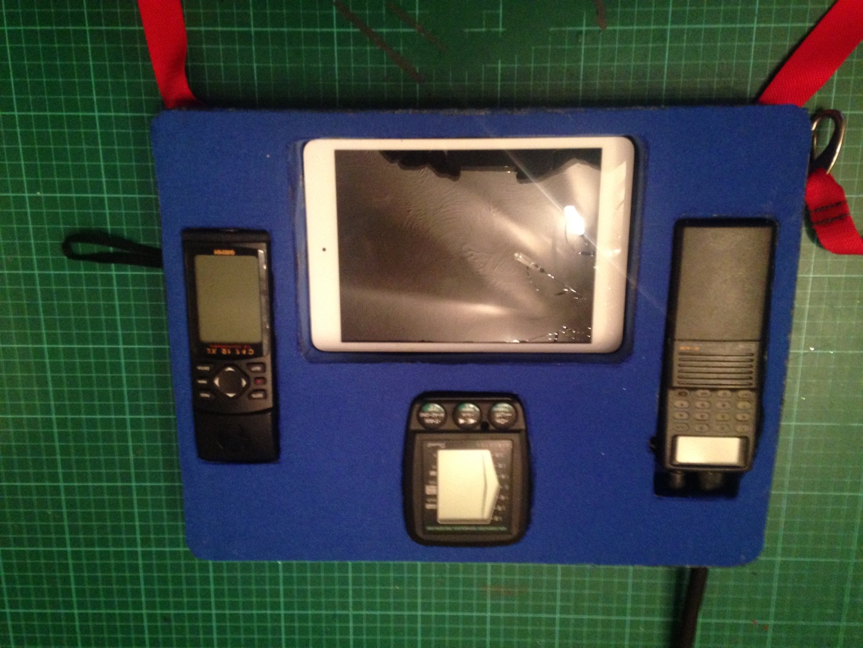
Final frontal view of the Mark two Instrument Pod.
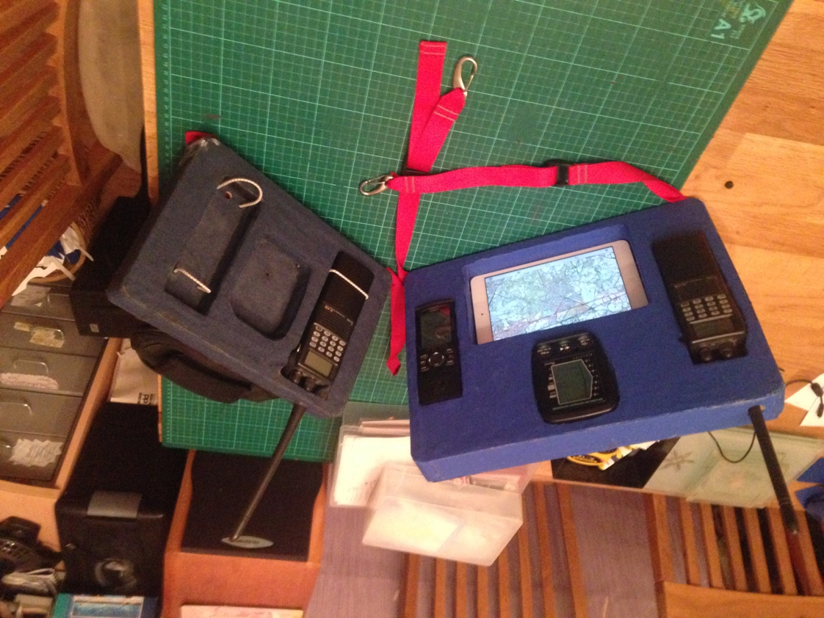
Comparison photo with its now retired brother! Should anyone wish to do a similar project and needs help –give me a shout

