Welcome to, Dare I say it? Yes, it’s the 100th Newsletter.

Who would have thought back in 2004 that here we would be, all these years later commenting on the successful publication of the 100th Newsletter? It simply begs belief that a stupid, rambling idiot, like me could possibly put together 100 of these things.
Contents

Ed Speak –
Reflecting on a Milestone.
Essential Extra’s
Adrian Browns
Instrument board
The Features Section –
N352JN in all three of its guises
The 2017 OMM.
Homebuilding.
Empty this month.
Interesting Photos
Mondovi Magic
Hunter Valley Australia
New Balloons
Nothing in Oct.
Gallery Pages
G-MOUZ
Manufacturer News/Events
Icicle dates
For Sale
Stock O-31.

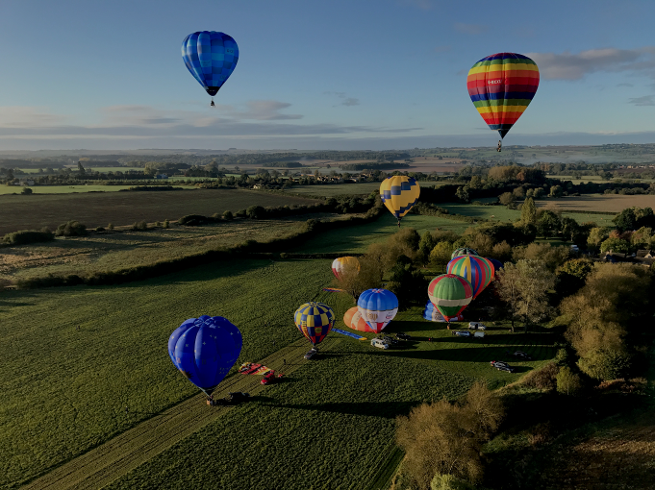
Its OMM time fo year –photo by Derek Maltby.

If I may just take a moment, I’d like to thank everyone who has ever contributed to the success of the magazine and to anyone who has taken time to read this stuff, thanks for being out there.
Sure this is a milestone, and it is in some ways apt that on the 100th issue we talk about the exploits of Hopper legend John Ninomiya, the guy who with his American Cloudhopper website inspired me to set up this forum.
To say John is a prolific flyer is doing him an injustice. But
when we look to see who gets the most hours out of
their hopper, I think he is the clear leader. In this episode we document
the story of his three “Fascination” hoppers. We also take time to
appropriately reflect on the 32nd Annual One Man Meet, this year
held in the Cotswolds.

For your reading this month we have:
- The John Ninomiya’s “Fascination” hoppers.
- Adrian Brown’s Instrument pod.
- The 32nd Annual One Man Meet.
- New Balloons / Second hand Sales updated.
- The Solo Record Flight Update.
- Interesting Photos
- Manufacturer News
- Cameron Stock O-31 for sale
- Cloudhoppers.org Merchandise expands.

Please send to me your items for inclusion in future editions of the newsletter to the email address below. Without any more waiting let’s get into the newsletter

Steve Roake- Editor: Steve.roake33@gmail.com

1, Ed Speak- Reflecting on a Milestone.

Time is a funny thing. One Hundred editions of the Magazine, and its gone in a flash. Seems like only five years ago I started the yahoo-groups embryonic facility and I can always remember the first person to ask me for membership was Don Piccard. I mean one of the founding lights in hopping asking me for membership – how cool was that?
Then for me getting our 1000th member on Facebook was mega. Now to have achieved 100 magazines is a real milestone and as this effectively “brand” continues to develop, small steps capitalising on its place in ballooning have led to a small but niche form of merchandising that will grow to sustain the hosting costs etc. What more can we do? What more do you all want I say? I love the impetus on Homebuilding that is out there, the Annex 2 thing just gets better and better. What would I like to do personally? My number one desire still remains to have a winter Alpine Hopper meet where two people (preferably both pilots), can attend a
small niche meet and take turns to fly their craft over a period of time
with other like minded people.
The thing with magazines is that you can influence the
manufacturers with ideas for what is required in the future, with
feedback and data. Number one on my list of these is still
currently a digital fuel gauge that sends the details of your capacity in real time to your phone or tablet. You know people knocked electronic maps when they arrived and swore blindly that O/s maps were here for life, but how many of you are now electronic? I think the same way with dip-tubes. Why do we physically need to see them? After all they only tell us the last 35% of the contents. So Happy 100th everyone and here’s to whatever is next.

2, The Essential Extras- Adrian Brown’s Flight Board.

When I sold G-UHOP the Um H-31B to Adrian Brown I knew he was an engineer. I knew through his previous manufacturing of Lindstrand Tools for hoppers that he had manufactured. He was at that time, very interested in my home made Instrument pod and told me of his future plans to create something bespoke for himself. At this year’s OMM he turned up with his creation and in his own words he talks us through what he has produced and Why.
Instrument Lap Board – by Adrian Brown

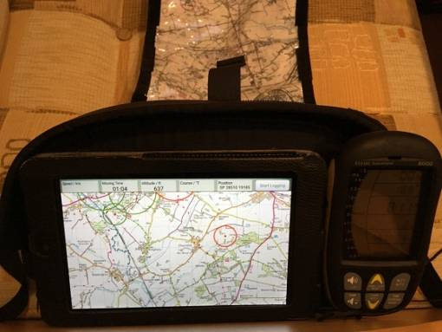Before my first Hopper flight in May 2014, I bought a Gin Gliders Flight Deck as recommended and demonstrated by Andy Austin. It has lots of straps, clips,
pockets and Velcro.
To attach it I used two of the straps to clip around the horizontal straps connecting to the 5 point harness. This held the flight deck off my lap and at an angle as shown in the photo. For landing the flap that the instruments are velcroed to, is pushed down, which then protects them in a padded pouch.
It has served me very well in carrying my Nexus 7, but having recently
upgraded to a larger tablet I’ve outgrown it and needed something
bigger. After speaking to various fellow hopper pilots about how they
manage and what they use, the decision was made to make my
own. Initial thoughts were to produce one similar in design to our
editor Steve Roake’s but tailored to my instruments.
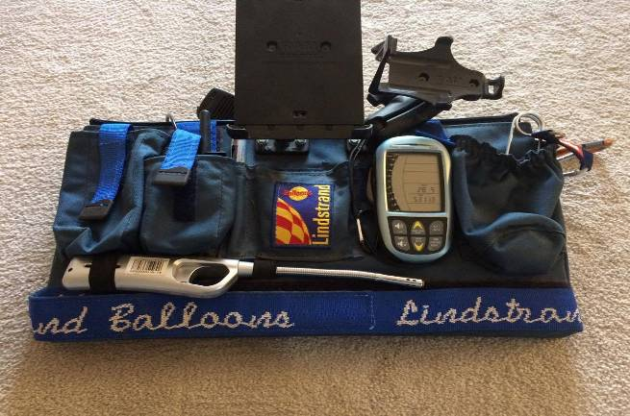
Dan Wilson has a Lindstrand Lap Board with an integral tank strap which wraps around both legs and fastens with Velcro – this feature is one I’d plan to adopt. It also has pockets for radios, strikers, maps and a couple of RAM mounts as shown for GPS and tablet. A great design, but as I understand a special commission made to order.

The big advantage that I see with these Lap Boards, are that everything can be set up, switched on and fitted to it, prior to it being passed and fastened to you. It can save so much time and avoids lanyards around your neck and things being clipped to the harness straps. If the conditions are not ideal, and the envelope unstable, the less time spent attaching half a dozen individual items the better.

Ideally, I wanted to have something ready to take to this year’s One Man Meet only a couple of weeks away. There wasn’t enough time for me to produce my version of Steve or Dan’s board as I didn’t have easy access to a sewing machine despite having the Cordura, foam (donated by Steve - thanks), load tape and clips.

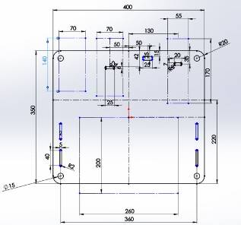However, my small engineering business has some state of the art CNC machines and a CADCAM system. So one evening, I went into work with a plan to design and machine a lap board from a 5mm sheet of clear polycarbonate we had in stock. I took all the instruments in to set the layout. A design was quickly modelled up during the time it took to warm the machine
up and write the program. A couple of extra slots were
added to give a few position options
for the lap strap. It’s a lot easier to
put extra features in from the
start rather than set up again
at a later date.

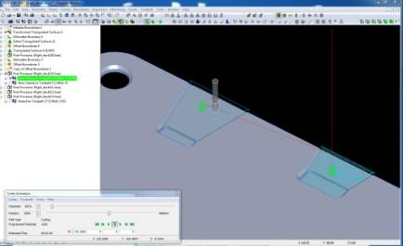
After a few hours all the machining was complete with a generous chamfer all around.

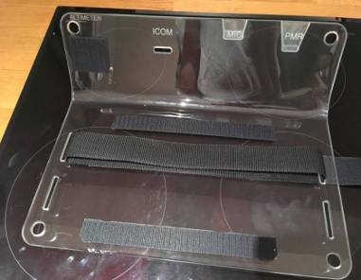The last operation was to bend the plastic by heating it. So before leaving work, I phoned my wife Alison and asked her to put the main oven on maximum. The plan was to support the flat area of the board (where the tablet sits) upside down, and allow the rest to droop over to the desired angle as it got hot. This was not entirely successful. The oven did heat up the plastic as it was sandwiched between some wood and two oven shelves. The plastic needed more persuasion to droop. So with the oven now switched off, the door open and the droop now pointing down out of the oven, an electric heat gun locally heated the bending point and a piece of wood aided the bend. This was far more controlled and successful.
Apologies for the image above, but I found photographing something transparent isn’t easy. From left to right is the altimeter, Icom, Icom mic and PMR. These positions were engraved so my very able crew know where everything goes. The altimeter has a lanyard hole and fixes with Velcro. The belt clip on the Icom snaps into a slot. Similar slots were tailored for the mic and PMR. The corner holes can be used for carabiners or lanyards. Velcro either side of the lap strap secures the tablet.
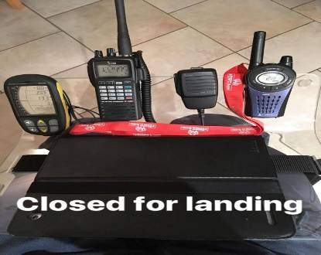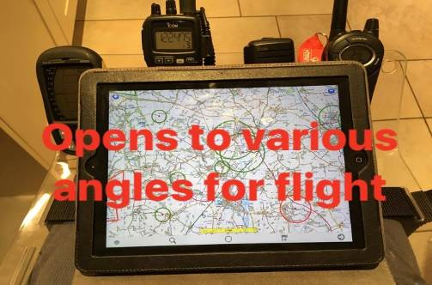
I always land on my left side where the envelope bag hangs to act as a cushion. The end tab
of the lap strap
(which threads
through the
board) is on the right hand side for quick removal after landing.
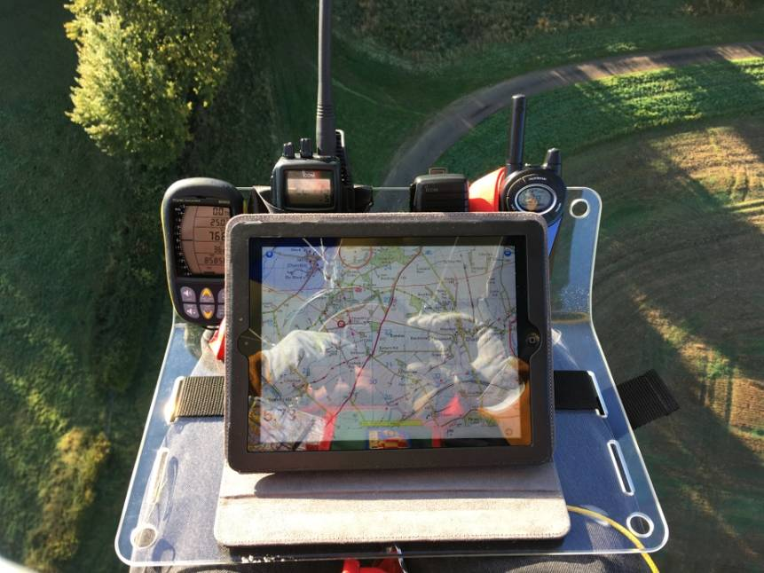

After several flights at the One Man Meet, I’m very pleased with the results. It attracted quite a lot of attention with some very welcome, constructive criticism; although I’m not sure a cup holder will feature in Mk2.
If you would like a bespoke Instrument Lap Board of a similar construction, maybe I can help.
Please get in touch ‘arb105@btinternet.com’ or through the Cloudhoppers FB page.

Many thanks for that Adrian -Ed
3,Features Section

John Ninomiya’s “Fascination” Hoppers

When you talk of John Ninomiya, most people will thing oh yes the cluster
ballooning guy(and quite rightly so). What a lot of people aern’t aware of
is that he is one of the most prolific hopper pilots I know of. Talking to him
recently and speaking with Ernie Hartt, you find out that John is a serious
hopper pilot who cut his teeth in an old Thunder and Colt 21A which
he flew under American Ultralight laws and so doesn’t consider the
150 hours he amassed as part of his licensed log. Having cut his
teeth on the 21A and living in California, John took the
opportunity to upgrade to N352JN(number1) when a 1996 Lindstrand 31A c/n 352 came up for grabs.The ex British G-BWMM arrived in february 1997 with low hours on it.

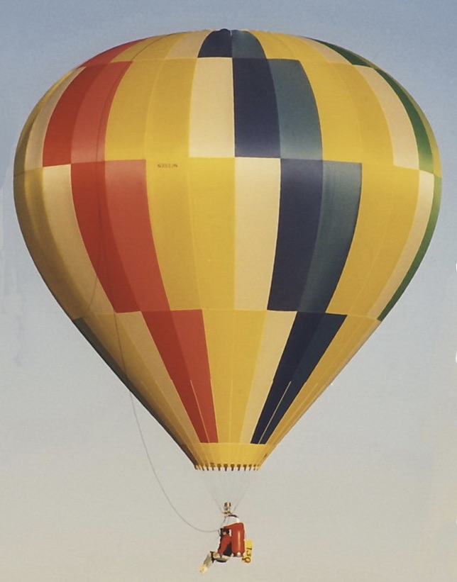

N352JN(1) photo with thanks by Sandy Mitchell.

Speaking with John the intial 31A was extensively flown logging an impressive 293 hours before being shipped off to Lindstrand USA for a full rebuild to become “Fascination 2”. These impressive hours blow to shreads my previous highest known hours which was 240odd by Steve Burden. Keeping the same crown ring and subsequent c/n “Fascination 2” featured a small modification to the colour scheme.

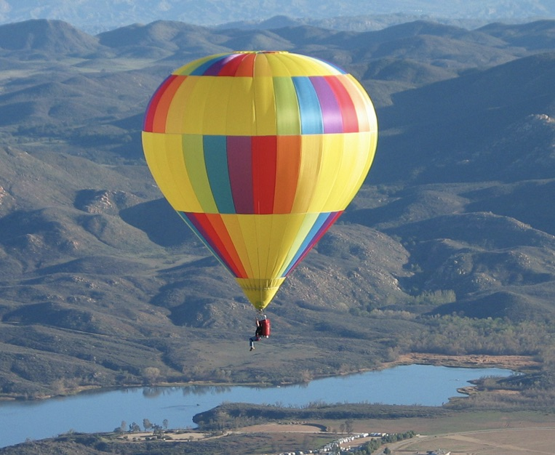

“Fascination 2” photo by John Ninomiya.

The second itteration of N352JN(2) featured a slightly revied colour
scheme and once again was extensively flown by John. Whilst the
fabric faded slightly through use it clearly didn’t suffer from

being flown regularly and was only rebuilt into Fascination 3 in 2017 which
coincided with a move to hotter and higher Arizona. With this in mind
the second hopper was respectfully retired from active duty with a total time of 593hours in the logbook (300 allocated tonumber 2), yet another testiment to a great built balloon .
As joked by John, having flown hoppers for some 21 years, he had gracefully bulked out by some 30 pounds, whilst Facination 2 had passed its annual inspection the advice that it would shortly need money spent on it seemed like the catylist to procuring LBL35A Fascination 3. Once again Built around the original crown ring by Lindstrand USA, number 3

Fascination 3 –photo by Ernie Hartt.

looks gorgeous in her new clothes, Photo taken by Ernie Hartt. Who is
to say that this one wont do another 300 hours? Thanks to both
Jonathan and Ernie for their help with this article.

Ed Note- If you have an interesting tale about your hopper I want to know about it .

The One Man Meet 2017- Cotswolds- by Steve Roake

The Annual One Man Meet (OMM) is now 32 years young. As is the tradition, the event has always moved every two years to a new region of the country and 2017 was the first year at a new venue. Following on from Derbyshire and a great location is a tough act to follow, and yet John Tyrrell (with two r’s) and Wendy Rousell scoured the country looking for possible locations that had the required elements that the event needed.Basically a nice central location(ie Hotel)with launch site close by, local supply of gas for those who would require it and a good source of socable venues for the attending crews. Spurred on by a tip from Alan Turner the location of the Cotswolds was investigated and subsequently chosen for 2017. Alan being a local resident, was invaluable in preparation for the weekend and ultimately the base was decided as The Mill House Hotel in Kingham Oxfordshire.

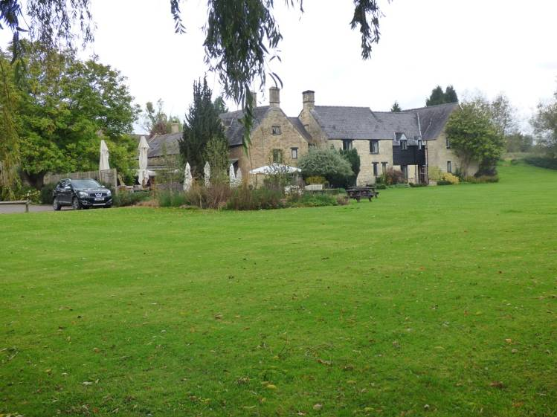

The Mill House Hotel
This charming Cotswold stone Building set in manicured grounds with
a trickling brook set in a rural location was perfect for the event
with adjoining field suitable for the hoppers linked to the grounds by a couple of small pedestrian bridges and a very short drive for retrieve vehicles.
Travelling to the venue on Friday morning my expectations for the prospects had veered as much as the weather had changed during the preceeding week. Going into the weekend my hunch was we had a good chance at flying on the Friday afternoon slot and on the Sunday morning with no further possibilities for the others due to a rain front moving through the region overnight Friday and clearing Saturday evening. We had secured an Air B&B accomodation some 3.7 miles north of the venue in Adlestrop with a lovely retired couple and the fact that every property in the small hamlet didn’t bother locking their front doors spoke volumes for the laid back approach of local people and their trust.
First briefing was scheduled for 3-30 in the Hotel car park, but I arrived early taking the time to familiarise myself with the surroundings and taking a late lunch. Slowly teams arrived and by the briefing some 20 teams were present and apparently keen to fly. My enthusiasm was slightly less working on then basis id seen 6-8knots surface winds and higher upstairs , but a conversation with Mark Schemilt (my local Virgin rides balloon pilot who is far more current than me), convinced me that the winds would drop later on. John did a role call , welcome speech and gave us a Met forecast of 6knots surface wind at 17-00 dropping to 4 knots by 19-00. All winds upstairs were 280 degrees with 500ft ones being 10knots and 2000ft at 13knots so decidely flyable. A nice high QNH of 1026 sealed the deal.
As a pilot but enthusiast first I always look to see what is coming to an event that is either rare or new and we had a few possibilities for this years OMM. Dave Such had agreed to bring G-CGFO a very rare 2009 built Um H-42 with little hours on it, and so this turned into the star of Friday night as he was first away from the launch field. There were quite a few recently registered craft flying with G-CJOI, G-CKIT (intelloper),G-CKJT,
G-CJRK and G-CJWY all featuring amongst the 19 that flew. We were
joined by two local balloons and all enjoyed a leisurely flight fairly low
level towards Enstone with my flight finishing within a mile or so of
the Airfield there. Some 6.8nm had been achieved in an hour
and a field sown with Clover which was being harvested for
Nitrogen proved too good to miss, joining Adrian Brown who had also selected it in G-UHOP(my old steed). It’s funny, but I wasn’t that keen to fly on the Friday evening slot,but spurred on by Mark Schemilt and watching others prepare I was delighted I decided to join them in the air. I have no idea why negativity was in my mind but the flight was delightful towards the east of our take off position and with lightish winds we flew over a lovely stately home mostly at low level which was possible by empty cut fields. Some 19 balloons took to the air including a couple of regular intelopers who were locals and it seemed a shame to think about landing but as the clock ticked towards sunset I thought prudency was required. I landed just short of Enstone village with a very charming farmer who got given a nice bottle for his accomodation of myself. It transpired later I had flown 6.8nm in my hour and burnt 29 litres of gas.

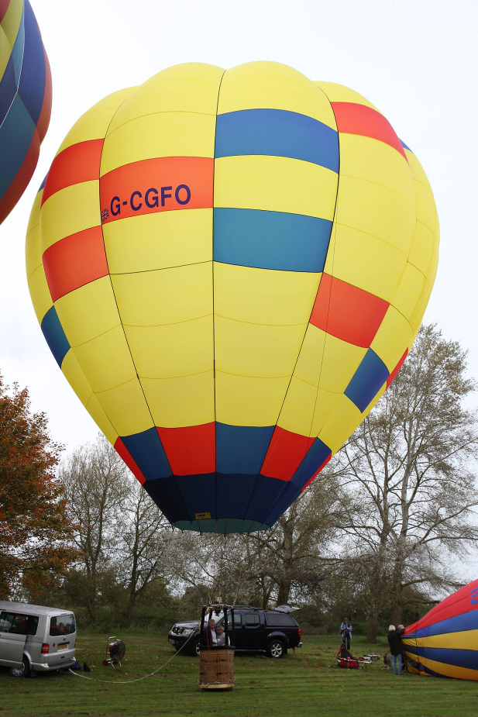

G-CGFO Um H-42- photo by Sandy Mitchell.

One very cool gesture to not go unnoticed. It was Darwin Peltam’s birthday and Simon Whatley graciously let Darwin fly his new Cameron O-26 G-CKSW, with Simon flying G-BKFG the older Ax-3, Nice gesture Simon.
Returning to the Hotel venue, there was a sit down meal for most of the
Entrants but we had decided that the choices werent to our tastes so contented ourselves in some pre dinner drinks with Mark Schemilt(who was only there for the day as Virgin Ballon rides work would call him away on the Sunday), and Josh Taylor and John Hilditch with Tim Ward, before legging it to Chipping Norton some 7 miles away for a lovely chinese meal.
A relatively early night meant that we were up bright and early for the Saturday morning blow out (briefing). This day was a known no flying day and so there was no surprise when both the morning and afternoon briefings concurred with what my Windy.com app was saying .You know 16knots gusting 31 doesn’t take a lot of thining about in a hopper. However with all things ballooning, 80% of ballooning is talking about it and 20% actually doing so when the Cameron Team suggested The Chequers pub in Churchill for the evening choice, may team joined John Hilditch and Tim Ward in attending the same pub which was very popular on a Saturday night, and they served a nice local Cotswolds Lager.
Now for the Highlight of the event. Sunday morning dawned early with light mist in the valleys and a gloroius sunrise which would ultimately burn off the mist. The Keen and the brave arrived for the briefing to have confirmation that indeed it was very flyable. Briefing notes said Surface winds of 5-6 at 290 degrees but in reality a lot less, 500ft winds of 310 degrees at 10knots and a QNH OF 1019. It was one of those lovely mornings where the sunshine shinning through the balloon fabric with some lingering mist gave the most etherial photographs as seen on the one above by Wendy Rousell. You smelt the early morning dew lingering on the cut grass, and you knew by the size of the crowd it was going to be a magical flight. The Morning also brought out the brand new Cameron O-26 for Tim Orchard and Marie banks for its maiden outing, Marie having
the honour with Tim flying their now sold older envelope G-BVRL
alongside.Including two regular balloons the morning saw 20
envelopes in the air , and Wendy told me that the local farmer had
rushed to get up in order to watch the specticle. Changes from

the first flight saw Dave Such flying his other envelope G-CBLO Lbl 42A, and Peter Mossman flying G-BXXU surely the prettiest ever build Colt31A.

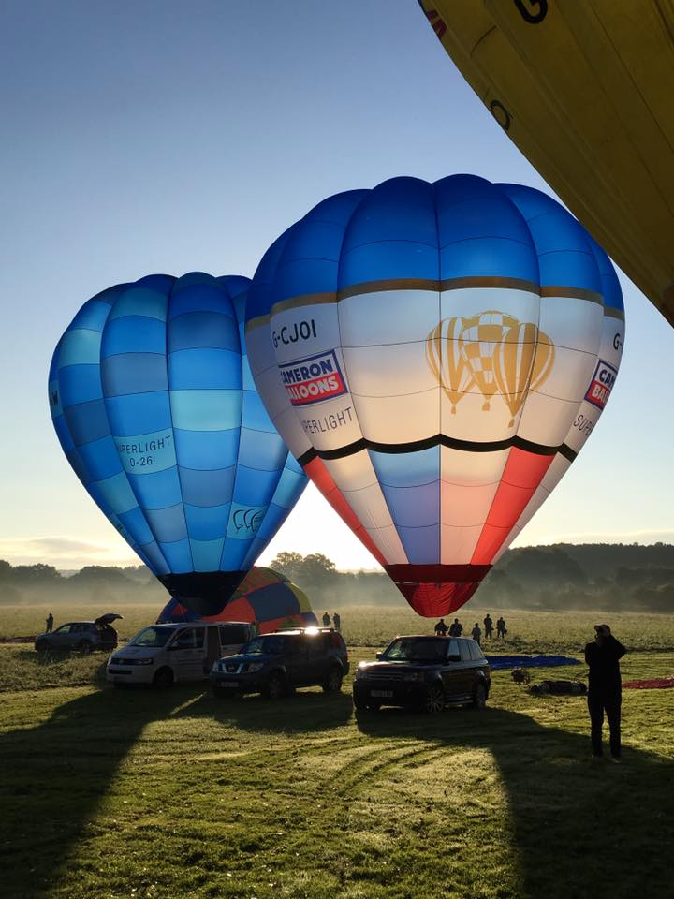

Sunday Morning rays and mist captured by Wendy Rousell.

Being towards the rear of the pack afforded me the sight of all those lovely hoppers bobbing low level across the deserted fields with surface winds of barely 2-3 knots it was glorious. If you wanted to catch the pack upstairs the wind was doing around 9-10 depending upon height. It was one of those stand out flights where you flew low level contour flying the rolling countryside, a real joy to be out enjoying the autumnal sunshine. Flights like these are the sort you need to remember deep into winter when you question why we fly. Just like the previous flight generally there was very little variance in direction with height but the track was further south easterly with the direction towards Cornbury park estates.
The initial inversion was very evident but as I didn’t take off until 08-30 burnt off quickly. Besides the occasional Horse rider, the morning was our own and once again it was lovely just to sit back in the chair and appreciate all that was around you. Meandering brooks, and branch railway lines crossed my track as I progressed. Littered amongst the cotswold stone housing that so appeals were the typical english quentisential churches that every village seems to have one of.
All too soon it was time to be sensible and as Cornbury estates appeared ahead of me and a swathe of forrest Id clocked that most had settled for just over an hours worth of flying and now there was some left on the surface. Picking a stubble field with already three hoppers in it I intiated my approach remaining high until I was far enough over to use the distinct
Left on the ground to track me back to my goal. Nicely placed mid field it was just a case of ensuring you had enough height to clear a small stone wall before arriving for your full stop landing. Once again another one hour five mins on the virtually new G-CJWY and another frugal 28.5 litres of spent propane. If you havent had the chance to fly one of these, id really suggest you ask your dealer for a go as they are such fun to fly. The added bonus of having my crew present for when I landed just added the icing to the cake.
Effortless packing away and we were off back to the Hotel for the 11-00 awards via our B&B where hot coissants awaited our return. I
thought that flying the Derbyshire peaks was gloroius , but this was also
stunning in a different style. When we did return to the launch site an
interested observer had arrived in his Robinson Helicopter sadly
missing all the spectacle as he was too late for the show. However
Im sure telling his friends about Wendy’s Wellies and the cock

up award would be reward in itself for the early morning flight and those mad hopper types he witnessed.

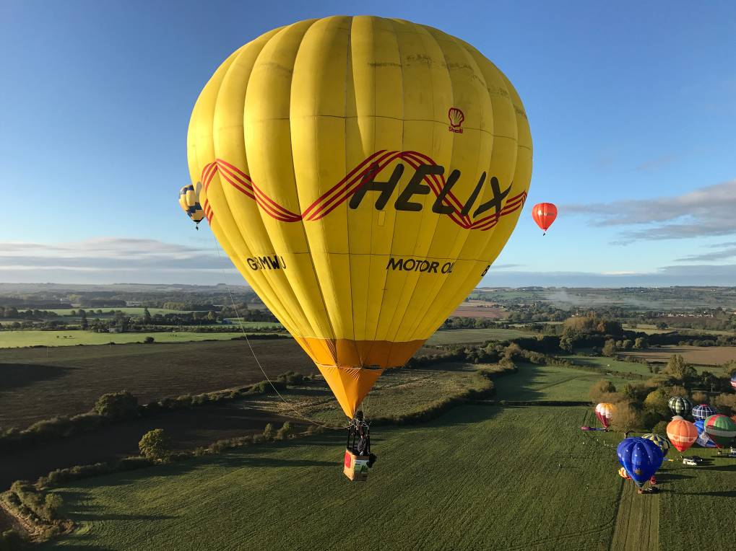
Superb Shot of Ian Chadwick taken by Derek Maltby.

And so it came to prizegiving and those award winning acolades that we all try to avoid so much. The first award was Wendy’s Wellies . These were awarded to Marie Banks for taking her first flight in G-MOUZ in front of everyone, she also got awarded some cheese. The Wooden Tit award was awarded to the Mill House Hotel as wouldn’t it be nice to return next year. The Cock up award was presented to John Hilditch who not only landed on Jeremy Clarksons land on Friday evening, but left his Striker on the launch field on Sunday morning. Dave Such got presented with a christmas pudding for being the first into the air on Friday night.
Alan Turner was presented with an award for his general help with
location and event support. The next recipient of an award was Helen
Ashworth(who crews for Adrian Brown) who double retrieved Derek
Maltby not once but twice with Derek’s wife.
Ian Chadwick received Hotel Chocolate for multiple landings
and a hedge excursion during a single flight. Then finally
there was another christmas Pudding awarded to Paul Spellward
who went out and bought a joint of Beef on the Saturday afternoon forgetting that he was staying in a Hotel.
So that was the 32nd OMM, nice but not a standout affair predominently due to the number of people who were absent diluting the whole thing. However we will return to the same area next year and im sure it will be as equally enjoyable. Many thanks to John and Wendy for their efforts !

Advertisement

4,Solo Record Flight – October Update.”Pin Back Your Ears”!

So without diplomacy and not holding back, here is where we are with this. A lot of people put a lot of hard work and effort into the Solo Record Flight for all of their efforts to be thwarted by a few selfish people who don’t want to comply with the request to return their filled in landing cards and photocopy of both the balloon and pilot logbooks. We are down to 11 of them who risk ruining the opportunity to register the New World Record since it is driven by lodging evidence with Guinness. So in no particular order I’m going to name those who haven’t complied. Without their co operation there is no record and everyone’s collective efforts are for nothing. What a total waste of time and energy.

Outstanding Landing forms required from (As of end of October)

Colin Butter
Andrew Walker
Joe Daly
Stefan Vogel
Daniel Bauer
Benoit Simon
Olivier Cuneot
Mike Woodcock
James Lawson
Filip Audenaert
Andy Booth.

If these individuals do not comply with the requests sent not only from me but directly from Cameron Balloons, quite simply all of our efforts will be for nothing and the whole thing will have been a waste of time.
Guinness too are being a right pain in the backside. They fail to recognise the category properly and despite my best efforts to try and educate these “experts”, they still are confusing our attempt with a regular balloon launch that took place previously at Bristol Fiesta where 128 “Normal” balloons took off in one launch window. I have offered to telephone them
to discuss the differences and as yet they refuse the offer. I am of the
opinion that we know more about this subject than they do.
Frustrated or what ???
Id like anyone who knows any of these individuals stick
please as this just isnt on.

5, Homebuilding Section-

Id love to say, here is another example of someone’s hmebuilding skills but unfortunately this month we have had no such submissions .

6, Interesting Photos.

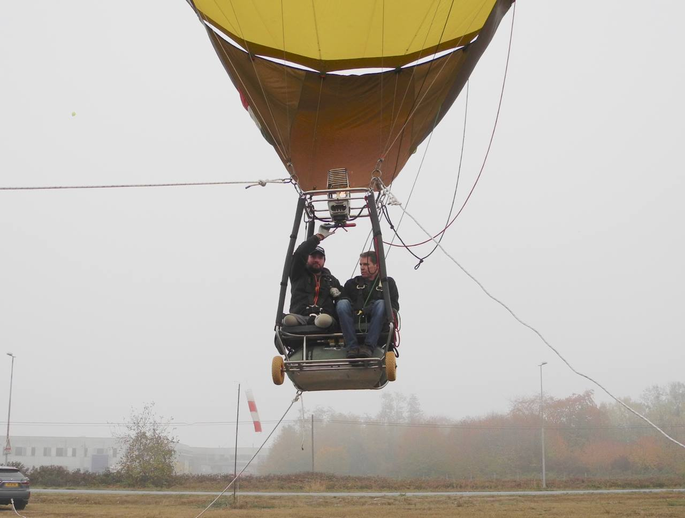

On October 21st a significant event took place in Mondovi Italy with the above
Duo Chariot. Arranged under the instruction of Giovanni Aimo, the Cameron
C70 Duo G-BYJX took flight for what is believed to be the first Double
Disabled pilot balloon flight. At the controls were Tim Ellison and Luke
Sinnott, so congratulations to both of them and let’s hope this is the first
of many future flights. Many thanks to Giovanni Aimo for the
photograph.

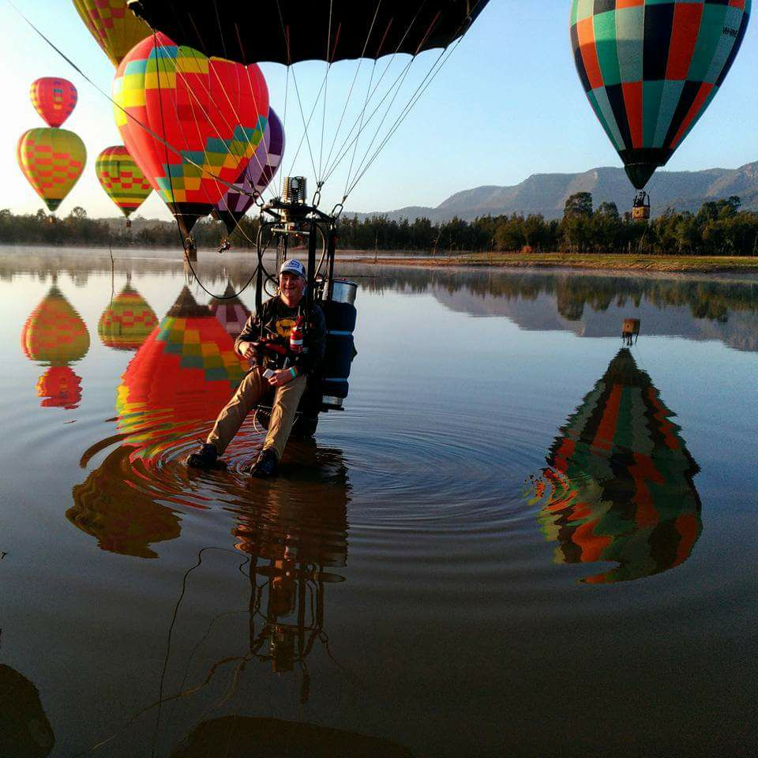

Hunter Valley Austrailia –Adam Barrow Style- great photo!

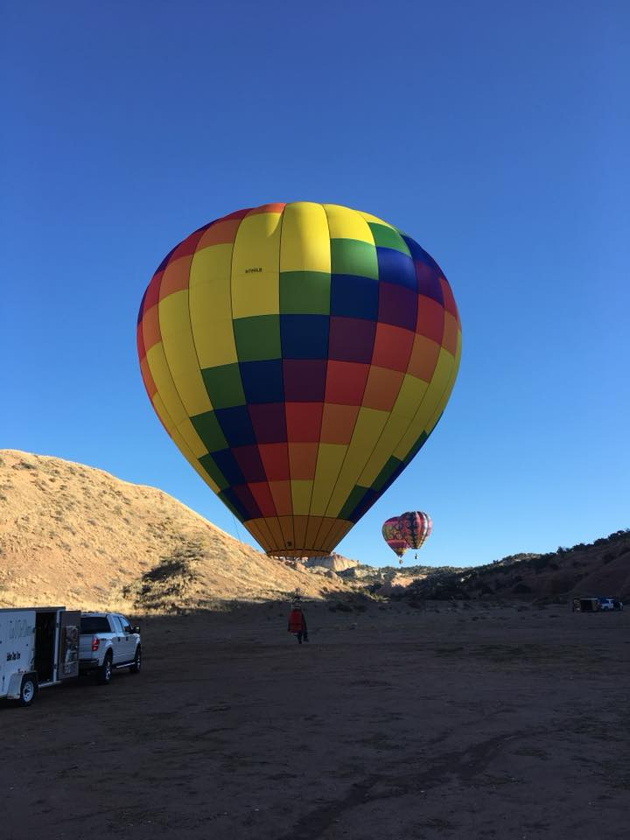

2017 Lindstrand 35A N788LB at the recent Gallop balloon Festival
Photo with many Thanks Lee Hooper of Lindstrand Technologies.

7, New Allocations This Month / Changes of Ownership

Following on from last month’s two new Cameron O-26’s, there is very little to report in this section of the Newsletter. There are a couple of deals occurring right now but until they are firmed up and completed I can’t elaborate. The most interesting of these will see a Paolo Bonnano Duo-chariot in the UK for the first time with a really trick Annex 2 envelope…watch this space!

Second Hand Movement

Second Hand sales have tended to slow down with one notable exception. the ex Tim Orchard / Marie Banks Lindstrand G-BVRL LBL21A is now with new
owners, although at time of press the details weren’t on the G-INFO website.

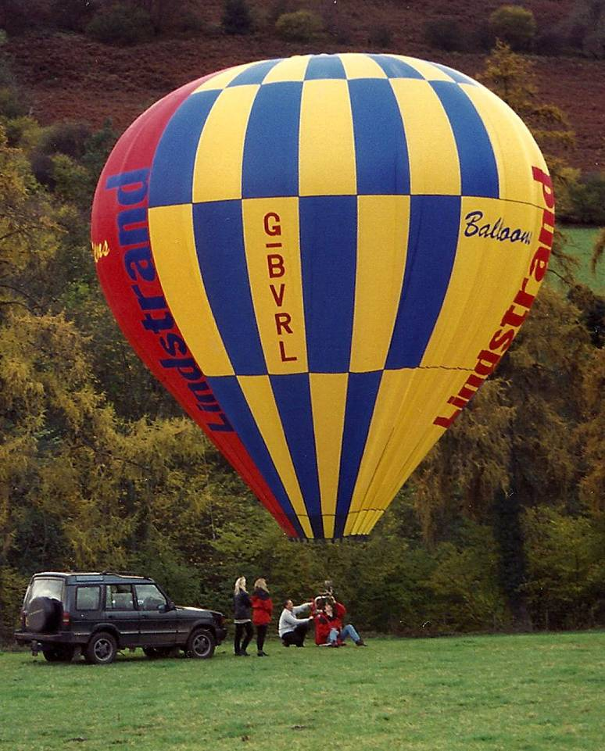

G-BVRL LBL21A seen here at the OMM in 1997.
7. Gallery Pages –

Your Editor’s choice of new and interesting hoppers and duo’s active in the
world of ballooning or good themed photos.

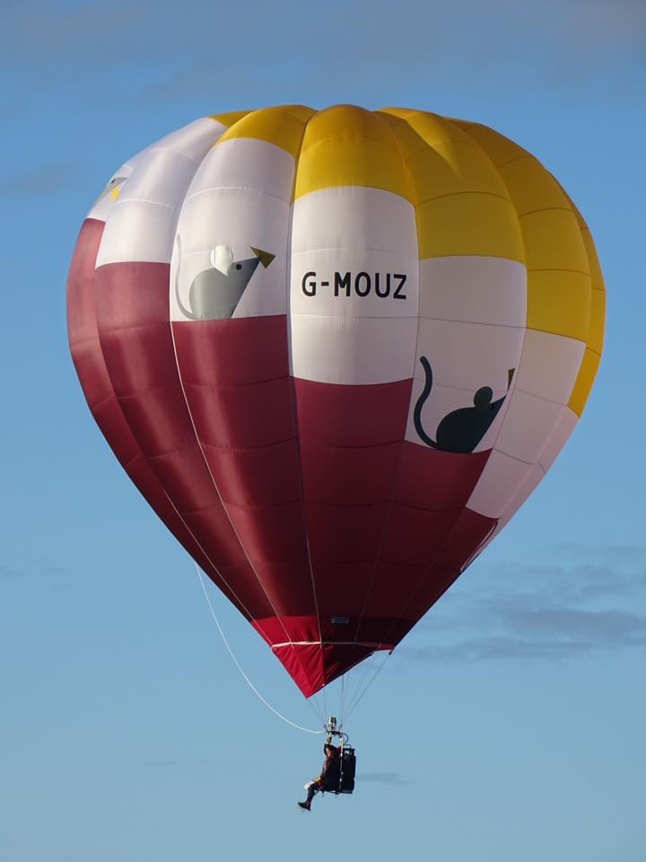

G-MOUZ Cameron O-26, first flight by Marie Banks
at the OMM – Superb photo by Keith Harbor.
Advertisement

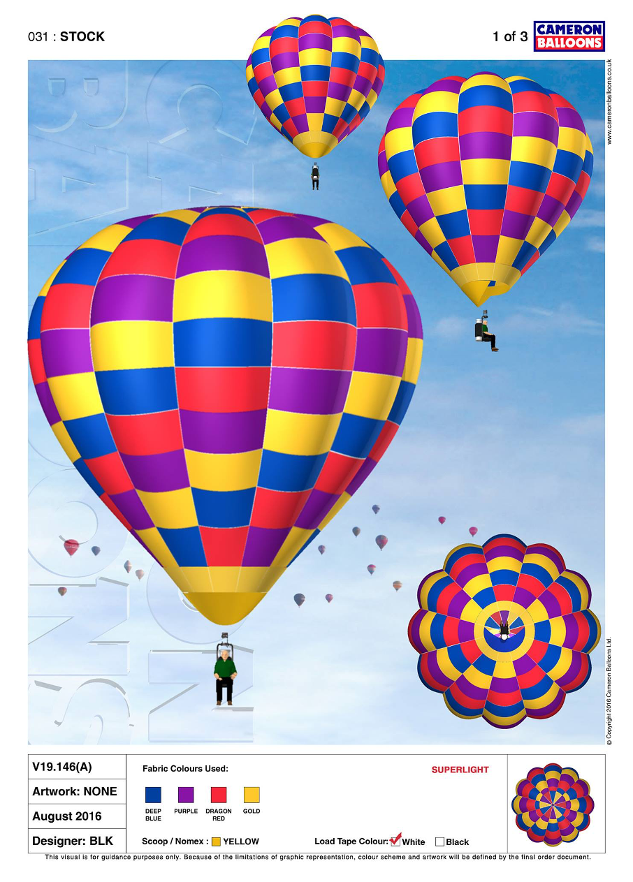
Pretty stock hopper from Cameron’s

Unbelievably still on a special offer deal from Cameron Balloons, is
This lovely stock hopper which is on a special price of £7800
using the discount code “Facebook Deal 01”. Contact Cameron Balloons in Bristol to secure this beautiful beast and enjoy the saving over list price.

8, Manufacturer / Event News / Industry News

Ron Griffin sadly failed to turn up to the OMM as expected with his lovely homebuilt RG-28 G-CFAI. It transpires that Ron had the perfect excuse in getting married on or around the dates. Speaking with him after the occasion he said he normally dosent miss balloon meets and will get his priorities right after the 5th of November , so expect to see the hopper soon. I only hope his new wife shares his sense of humour, but congratulations from all of us.

Cloudhoppers.org Merchandise

Just an update on the Cloudhoppers merchandising and how well it has been received so far. Hopper mugs are selling far better than i had ever imagined (thanks very much), with a strong and steady stream of interest from the marketplace.
Bung kits are proving popular too with over five sets of Cameron Millenium Bung Kits now out in circulation, including our first export set to Gary Palmer in South Dakota USA. Just a reminder, these aernt limited to Cameron Products , we also supply for Lindstrand , Ultramagic and also can supply for burner frames , baskets , inflation fan feet and basically anything tubular you wish to cap off and prevent damage potential. Simply email with your diameter of tubing requirements and number of bungs required to the email address atthe top of the newsletter.
Moving forward , again driven only by demand if its there, the next product we would like to offer you is a delightful simple yet elegent Cloudhoppers.org Clock. This 9 inch diameter clock is simplicity itself which makes it rather bespoked . Should demand exceed five units then i
will be offering them for sale at a lovely price of £25 plus postage and
packaging. The whole look is one of those less is more things , and
im sure it wont look out of place in either an office or kitchen
environment . We are also looking into doing another design of
it with a beautiful full colour photograph in the centre of the
design.Please also once again contact me with your
requirements for clocks .
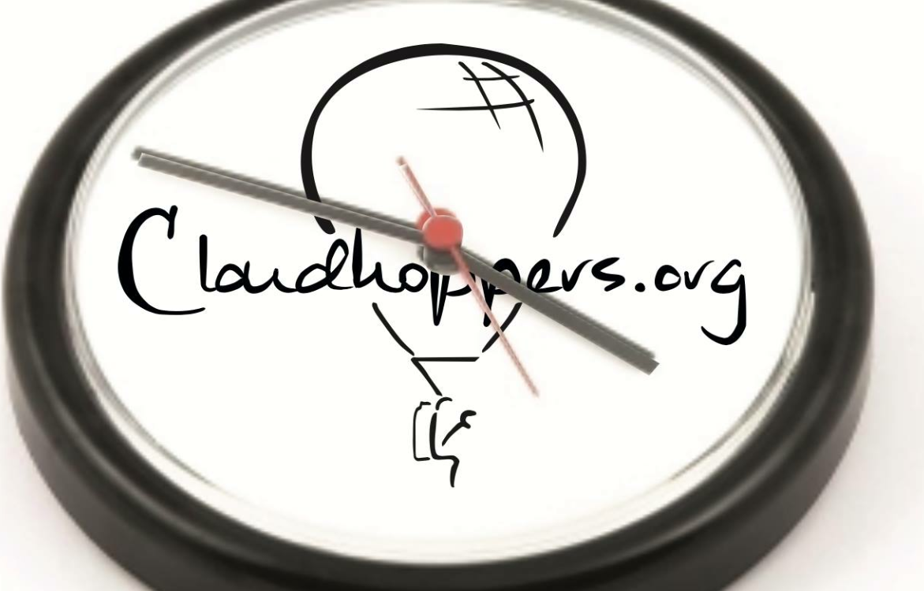

Item Number 3 – the Cloudhoppers.Org Clock.

Icicle Refrozen Balloon meet 2018

Dates are now out for the 2018 Icicle meet with the venue back at the Donnington Grove Hotel in Newbury as it was this year. The dates are January 6th and 7th hosted by the 3/4/40 balloon club as usual.

Icicle Refrozen Balloon Meet 2018
Registration & Dinner Bookings now OPEN!

The Icicle Refrozen Balloon Meet Committee are delighted to announce
that the Icicle Refrozen Balloon Meet 2018 will take place on Saturday
6th & Sunday 7th January 2018 at Donnington Grove Country Club on
the North West edge of Newbury, Berkshire. The 3-4-40 Region BBAC
welcomes balloonists from across the country to attend this iconic
event which is a spectacular location for flying, accommodation, trade stands & social. The Icicle Refrozen Balloon Meet remains informal, un-sponsored and open to all balloonists.
We invite you to join us for dinner on the Saturday evening, where we are delighted to announce that Josep Maria Llado, CEO and founder of UltraMagic Balloons will be our guest speaker. Josep and his team started ballooning in 1978 with their first Balloon “Rodamón” and shortly after started work on a larger homebuilt envelope for an expedition to Africa. The expedition to Africa started in 1980 and lasted 11 months and involved 40 flights from Zanzibar (Tanzania) to Kisiangani (Zaire).
After the project was completed, Josep and his team started designing and building balloons in Spain under the name of UltraMagic Balloons. In recent years, Josep has completed flights across Mt Kiliminjaro, the Alps, Madagascar and Aconcagua the highest mountain outside of Asia at 6,961 metres (22,838ft). We are extremely delighted to welcome Josep who will be sharing memories of these fantastic flights.
Further details, including registration and dinner booking forms are now LIVE and can be accessed via the Icicle Refrozen Balloon Meet website -www.icicle-refrozen.com.
We look forward to seeing you in January!

Many Thanks to Jonathan Harris for the update .
For all the advanced information and an entry form contact Geoff
Lescott via the email address: geoff.lescott@gmail.com .

Current Membership of the Facebook page is 1125 and still rising
steadily. And so that was the 100th (October) edition of the Newsletter, hope you all enjoyed it.

Cloudhoppers Newsletters 2004-2017
Current Membership of the Facebook page is 1125 and still rising
steadily. And so that was the 100th (October) edition of the Newsletter, hope you all enjoyed it.

Fly Safe people and catch you for the next “100” Steve Roake

All articles for inclusion in future issues will be gratefully received by
Your Editor. Please forward them to steve.roake33@gmail.com
and feedback good, bad or indifferent is always welcome.
Views aired by contributors may not be those of the Editor.

For all previous newsletters visit www.cloudhoppers.org/Newsletters.

© Cloudhoppers.org Issue Number 100 October 2017

